Name: Mayan Rhys Sequeira
SRN: PES2UG23CS332
Section: F

- Which kernel was most effective for this dataset?
The RBF kernel performed best on the Moons dataset, as it captured the non-linear shape of the data and achieved higher classification accuracy compared to the linear and polynomial kernels.
- Why might the Polynomial kernel have underperformed here?
The Polynomial kernel tends to overfit when data is noisy or non-linearly separable with irregular boundaries, which causes it to perform worse than the RBF kernel for the Moons dataset.

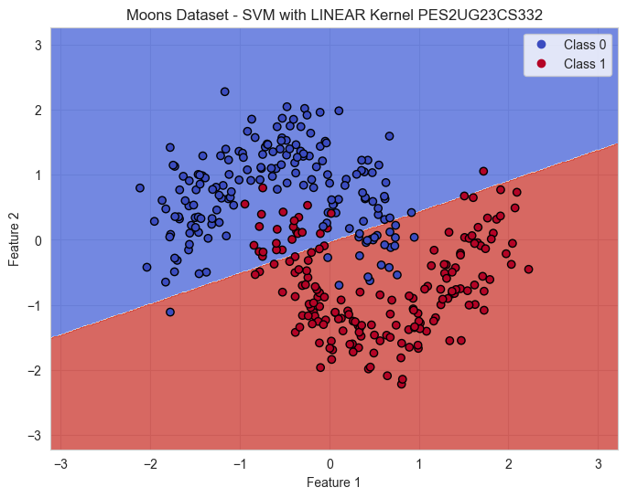
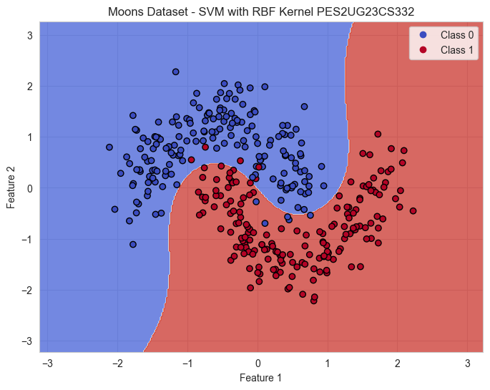
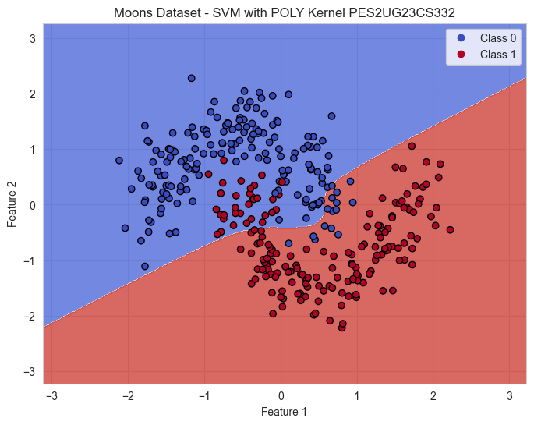

- Which kernel was most effective for this dataset?
The Linear kernel performed best for the Banknote dataset because the data is nearly linearly separable, allowing a simple hyperplane to classify the samples accurately.
- Why might the Polynomial kernel have underperformed here?
The Polynomial kernel introduced unnecessary complexity for a dataset that is linearly separable, leading to slight overfitting and reduced generalization on the test set.
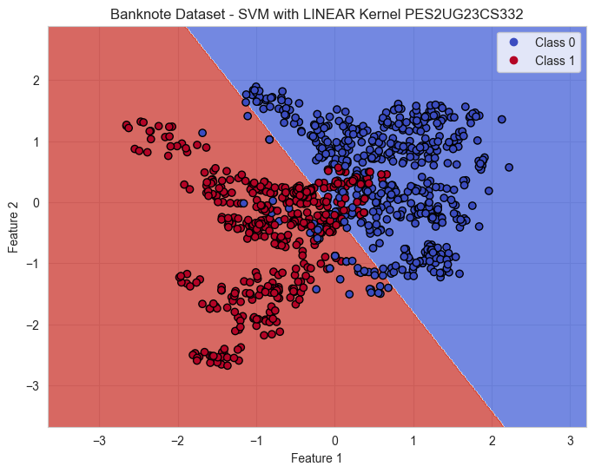
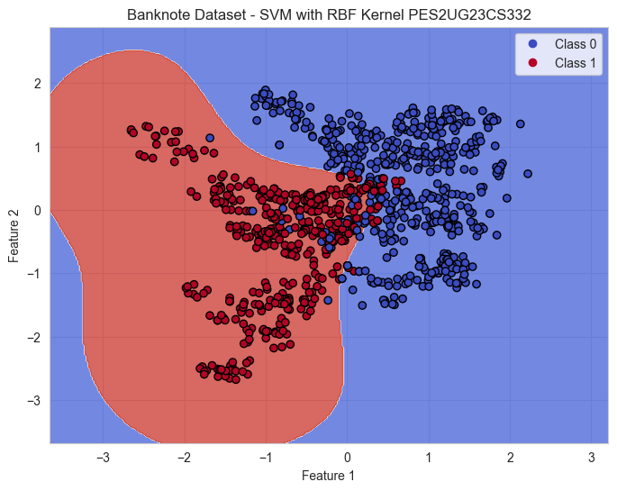
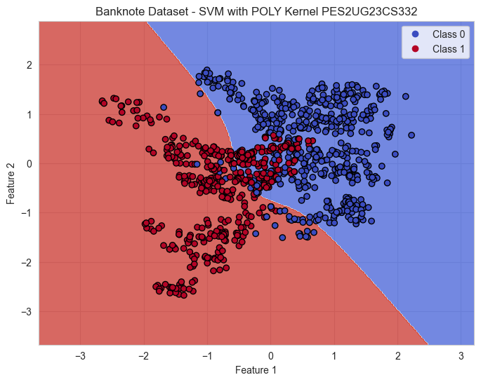

- Which margin (soft or hard) is wider?
The soft margin (C=0.1) produces a wider margin because it allows more flexibility and tolerance for misclassifications.
- Why does the soft margin model allow “mistakes”?
The soft margin SVM trades off perfect classification for a larger margin, improving generalization by allowing some misclassified points near or within the margin
- Which model is more likely to be overfitting and why?
The hard margin SVM (C=100) is more likely to overfit since it forces perfect classification on training data, making it sensitive to noise and outliers.
- Which model would you trust more for new data and why?
The soft margin SVM (C=0.1) is more reliable for unseen data because it generalizes better by avoiding overfitting to training samples.
